KENDRIYA VIDYALAYA KALIMPONG

MULTIDISCIPLINARY PROJECT Session 2024-2025

CLASS : III

Guidelines for the project :-

***Complete and submit the project in time.***

***Write the project in A4 size paper and make a single file for all the subjects.***

***You can use different colour pens except Red pen.***

***Write one side of the paper only.***

(1) FRONT PAGE :-

1. Name of the Student :-

2. Roll No :-

3. Class :- V

Name of the School :- KENDRIYA VIDYALAYA KALIMPONG

Title of the Project :- TIME

Name of the Guide Teachers :-

Mrs. Dawa Dolma Bhutia

Mrs. Neelam Shahi

Mr. Rohit

Mrs.Anu Chettri

2Nd Page

(2) INDEX PAGE :-

Index

|  |  |  |  |  |
| --- | --- | --- | --- | --- |
| **Sl No** | **TOPICS** | **FROM PAGE** | **TO PAGE** | **REMARKS** |
| 1 | Certificate |  |  |  |
| 2 | Acknowledgement |  |  |  |
| 3 | MDP English |  |  |  |
| 4 | Hindi |  |  |  |
| 5 | Maths |  |  |  |
| 6 | EVS |  |  |  |

**3rd PAGE**

CERTIFICATE

This is to certify that **_Student name___** student of Class ___V____ has successfully completed his project on

___TIME__ under the guidance of **( All subject Teachers’ names ) KV Kalimpong** for the academic session **2024-2025.**

Subject Teacher Date:

**4Th Page**

ACKNOWLEDGEMENT

I would like to express my heartfelt gratitude to my subject teachers

**( All subject Teachers’ names )** for their guidance, my honourable principal **( Principal’s name)** for providing me all the facilities in our school.

I would also like to express special thanks to my parents and friends for helping me to complete this project.

**KENDRIYA VIDYALAYA KALIMPONG**

**AUTUMN BREAK HOLIDAY HOMEWORK SESSION ( 2024 –25)**

**CLASS : III SUBJECT : MATHEMATICS TEACHER : Mrs. NeelamShahi**

Add the following

234 + 136

138 + 56

286 + 268

Subtract the following

154 – 143

338 + 56

586 + 368

Practice multiplication and solve the following

23 x 6

48 x 9

145 x 5

678 x 4

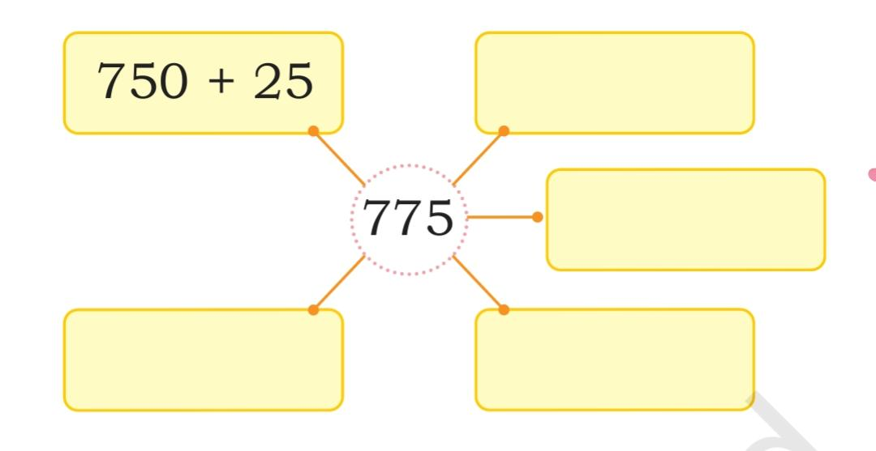Write the given numbers as the sum of two numbers .

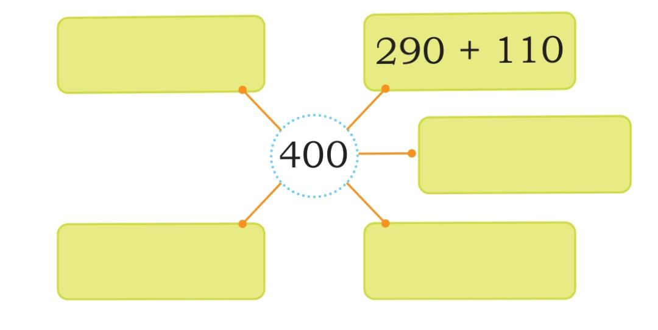

Learn tables upto 15.

|  |  |
| --- | --- |
|  |  |

-------------------------------------------------

**KENDRIYA VIDYALAYA KALIMPONG**

**AUTUMN BREAK HOLIDAY HOMEWORK SESSION ( 2024 –25)**

**ClASS III ENGLISH HOLIDAY HOMEWORK**

**CLASS 03 - ENGLISH**

|  |  |  |
| --- | --- | --- |
|  | **Section A** |  |
| 1 | Fill in the blanks   1. One child, many ________. 2. One fox, many ________. 3. One duck, many ________. 4. One goose, many ________. |  |
| 2 | Add ‘ful’ to make a word.   1. The children are ________. (play) 2. The flowers are ________. (beauty) 3. The books are ________. (use) 4. The vegetables are ________. (plenty) |  |
| 3 | Add ‘ly’ to make a word   1. The new shoes are ________. (love) 2. He is ________ smart. (real) 3. We should eat ________. (slow) 4. Let us sing ________. (soft) |  |
| 4 | Write five sentences on how you help at home.  I help my mother ________  I help my father ________  I also help my brother in ________  I also help my sister with ________  I do ________ in the house. |  |
| 5 | Add ‘ish’ to make a new word.   1. That girl is always crying. She is ________. (child) 2. I slipped on a banana peel. I feel ________. (fool) 3. My sister is ________. (baby) |  |

KENDRIYA VIDYALAYA KALIMPONG

SESSION ( 2024 –25)

AUTUMN BREAK HOLIDAY HOMEWORK

CLASS : III SUBJECT EVS TEACHER : Mrs.Anu Chettri

Note: Do the homework in separate A4 sheets.

Q1. Why water is important for us?

Q2. What do you mean by rainwater harvesting?

Q3. Name atleast Five natural and man made sources of water along with pictures?

**केंद्रीय विद्यालय कालिंपोंग**

**शरदकालीन अवकाश गृहकार्य 2024 – 25**

**अध्यापक - रोहित कुमार कक्षा – 3 विषय – हिन्दी**

**Note: Do the homework in separate A4 sheets.**

**प्रश्न – 1 अलग – अलग अवसरो पर कौन – कौन से पकवान बनाए जाते है?**

**उनके नाम लिखो और चित्र चिपकाओ**

**प्रश्न – 2 अपने स्कूल का वर्णन कीजिए और आपको वहाँ क्या – क्या पसंद है लिखिए**

**और अपने स्कुल का चित्र ।**

**KENDRIYA VIDYALA KALIMPONG**

**AUTUMN BREAK HOMEWORK**

**Class-III COMPUTER**

**1. Draw and Label Parts of a Computer: Draw a computer and label its main parts (like monitor, keyboard, CPU, and mouse).**

**2. Write Five Uses of Computers: Write a few sentences about five different ways we use computers in our daily lives (like in schools, hospitals, etc.).**

**KENDRIYA VIDYALAYA KALIMPONG**

**MULTIDISCIPLINARY PROJECT Session 2024-2025**

**CLASS : IV**

Guidelines for the project :-

***Complete and submit the project in time.***

***Write the project in A4 size paper and make a single file for all the subjects.***

***You can use different colour pens except Red pen.***

***Write one side of the paper only.***

(1) FRONT PAGE :-

1. Name of the Student :-

2. Roll No :-

3. Class :- V

Name of the School :- KENDRIYA VIDYALAYA KALIMPONG

Title of the Project :- TIME

Name of the Guide Teachers :-

Mrs. Dawa Dolma Bhutia

Mrs. Neelam Shahi

Mr. Rohit

Mrs.Anu Chettri

2Nd Page

(2) INDEX PAGE :-

Index

|  |  |  |  |  |
| --- | --- | --- | --- | --- |
| **Sl No** | **TOPICS** | **FROM PAGE** | **TO PAGE** | **REMARKS** |
| 1 | Certificate |  |  |  |
| 2 | Acknowledgement |  |  |  |
| 3 | MDP English |  |  |  |
| 4 | Hindi |  |  |  |
| 5 | Maths |  |  |  |
| 6 | EVS |  |  |  |

**3rd PAGE**

CERTIFICATE

This is to certify that **_Student name___** student of Class ___V____ has successfully completed his project on

___TIME__ under the guidance of **( All subject Teachers’ names ) KV Kalimpong** for the academic session **2024-2025.**

Subject Teacher Date:

**4Th Page**

ACKNOWLEDGEMENT

I would like to express my heartfelt gratitude to my subject teachers

**( All subject Teachers’ names )** for their guidance, my honourable principal **( Principal’s name)** for providing me all the facilities in our school.

I would also like to express special thanks to my parents and friends for helping me to complete this project.

**KENDRIYA VIDYALAYA KALIMPONG**

**SESSION ( 2024 –25)**

**AUTUMN BREAK HOLIDAY HOMEWORK**

**CLASS : IV SUBJECT : MATHEMATICS TEACHER : Mrs. Neelam Shahi**

1. **Draw a circle and label its parts .**

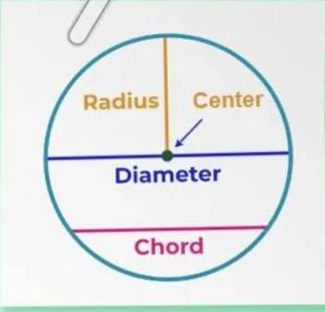

1. **Multiply the following:** 
   1. **25 × 36**
   2. **42 × 24**
   3. **429 × 72**
2. **Divide the following:** 
   1. **426 ÷ 12**
   2. **324 ÷ 18**
   3. **2348 ÷ 6**
3. **Learn tables upto 15.**

|  |  |  |
| --- | --- | --- |
|  | **Section A** |  |
| 1 | This is a park where children talk to different animals and birds. Write four sentences about the picture. Use capital letters where required, complete sentences, and punctuation.  image  Now colour the picture. |  |
| 2 | Some words have similar sounds, but different meanings. Choose the correct word from the box and fill in the blanks.   1. The bird sits on a ________. (bow, bough) 2. The squirrel has a long ________. (tail, tale) 3. I have to leave at ________. (too, two) 4. This sum is ________. (right, write) 5. I can ________ the bird’s song. (hear, here) 6. Do you ________ a secret? (no, know) 7. The King sits on the ________. (thrown, throne) 8. He is our school ________. (principal, principle) |  |

|  |  |
| --- | --- |
|  | Kendriya Vidyalaya Kalimpong |

**Class IV English Holiday Homework**

**CLASS 04 – ENGLISH**

KENDRIYA VIDYALAYA KALIMPONG

SESSION ( 2024 –25)

AUTUMN BREAK HOLIDAY HOMEWORK

CLASS : IV SUBJECT EVS TEACHER : Mrs.Anu Chettri

Q1. List 5 ways to conserve water?

Q2. Name and paste atleast Five picture of renewable and non renewable sources of energy?

Q.3 List 5 sources of water pollution ?

केंद्रीय विद्यालय कालिंपोंग

शरदकालीन अवकाश गृहकार्य 2024 – 25

अध्यापक – रोहित कुमार कक्षा – 4 विषय – हिन्दी

प्रश्न – 1 शेर पर निबंध लिखिए और उसका चित्र बनाइए ।

प्रश्न – 2 हमें अपने आस – पास स्वच्छता क्यों रखनी चाहिए ।

**KENDRIYA VIDYALA KALIMPONG**

**AUTUMN BREAK HOMEWORK**

**Class-IV COMPUTER**

**1.** Create a PPT slide showcasing your favorite dishes you enjoyed during your holidays. Prepare 4 slides will background colour , few paragraph about the dish you mentioned

KENDRIYA VIDYALAYA KALIMPONG

MULTIDISCIPLINARY PROJECT Session 2024-2025

CLASS : V

Guidelines for the project :-

***Complete and submit the project in time.***

***Write the project in A4 size paper and make a single file for all the subjects.***

***You can use different colour pens except Red pen.***

***Write one side of the paper only.***

(1) FRONT PAGE :-

1. Name of the Student :-

2. Roll No :-

3. Class :- V

Name of the School :- KENDRIYA VIDYALAYA KALIMPONG

Title of the Project :- TIME

Name of the Guide Teachers :-

Mrs. Dawa Dolma Bhutia

Mrs. Neelam Shahi

Mr. Rohit

Mrs.Anu Chettri

2Nd Page

(2) INDEX PAGE :-

Index

|  |  |  |  |  |
| --- | --- | --- | --- | --- |
| **Sl No** | **TOPICS** | **FROM PAGE** | **TO PAGE** | **REMARKS** |
| 1 | Certificate |  |  |  |
| 2 | Acknowledgement |  |  |  |
| 3 | MDP English |  |  |  |
| 4 | Hindi |  |  |  |
| 5 | Maths |  |  |  |
| 6 | EVS |  |  |  |

**3rd PAGE**

CERTIFICATE

This is to certify that **_Student name___** student of Class ___V____ has successfully completed his project on

___TIME__ under the guidance of **( All subject Teachers’ names ) KV Kalimpong** for the academic session **2024-2025.**

Subject Teacher Date:

**4Th Page**

ACKNOWLEDGEMENT

I would like to express my heartfelt gratitude to my subject teachers

**( All subject Teachers’ names )** for their guidance, my honourable principal **( Principal’s name)** for providing me all the facilities in our school.

I would also like to express special thanks to my parents and friends for helping me to complete this project.

|  |  |
| --- | --- |
|  |  |
|  |  |

**KENDRIYA VIDYALAYA KALIMPONG**

**English Holiday Homework**

|  |  |  |
| --- | --- | --- |
|  | **Questions for English Holiday Homework** |  |
| 1 | Fill in the grid given below by assigning qualities to each person. Some clues are given here to help you.  Clues   * Sangeeta lends her pencil to her partner. * Nirav is also called a chatterbox. * Pranav recently saved a cat from drowning in the lake. * Megha is just the opposite of Nirav. * Mithila always teases everyone. * Ritu is always seen with a book in hand.   image | **[12]** |
| 2 | A notice tells and **who, when, where** and **what** .  The girls and boys of Class V wrote notices for the bulletin board.  Read Sheela’s notice. Discuss the questions that follow. image   * Who was to meet? * When were they to meet? * Where were they to meet? * What were they to do? | **[8]** |

**CLASS 05 - ENGLISH**

**KENDRIYA VIDYALAYA KALIMPONG**

**SESSION ( 2024 –25)**

**AUTUMN BREAK HOLIDAY HOMEWORK**

**CLASS : V SUBJECT : MATHEMATICS TEACHER : Mrs. Neelam Shahi**

1. **In a map of India write the name of all the states and mention**

**Scale of Map and Directions.**

1. **Draw a map of your house.**
2. **Multiply the following:** 
   1. **23 × 36**
   2. **242 × 54**
   3. **429 × 72**
3. **Divide the following:** 
   1. **625 ÷ 12**
   2. **324 ÷ 18**
   3. **2348 ÷ 6**
   4. **4089 ÷ 22**
4. **Learn tables upto 20.**

KENDRIYA VIDYALAYA KALIMPONG

SESSION ( 2024 –25)

AUTUMN BREAK HOLIDAY HOMEWORK

CLASS : V SUBJECT EVS TEACHER : Mrs.Anu Chettri

Q1. What do you mean by transportation ?

Q2. Name and paste atleast six pictures of transportation that is used in hilly or mountainous region?

Q3. On the outline map of India Mark three oil refinery and seven sisters of India?

केंद्रीय विद्यालय कालिंपोंग

शरदकालीन अवकाश गृहकार्य 2024 – 25

अध्यापक – रोहित कुमार कक्षा – 5 विषय – हिन्दी

प्रश्न – 1 हमें योग क्यों करना चाहिए विभिन्न प्रकार के योग के चित्र चिपकाइए

प्रश्न – 2 जल पर निबंध लिखिए

**KENDRIYA VIDYALA KALIMPONG**

**AUTUMN BREAK HOMEWORK**

**Class-V COMPUTER**

**1. Create a Presentation: Prepare a small 4-5 slide presentation on the topic "Importance of Computers in Our Lives" using Microsoft PowerPoint or any other software.**