**कक्षा 11वीं हेतु**

**शरदकालीन अवकाश के लिए गृहकार्य**

**वंशीधर की ईमानदारी को आप किस दृष्टिकोण से देखते हैं? क्या आप उसे सही ठहराते हैं या समाज की आलोचना को जायज मानते हैं? ‘नमक का दारोगा’ पाठ के आधार पर तार्किक उत्तर लिखिए।**

**मियाँ नसीरुद्दीन तीसरी पीढ़ी के हैं जिसने अपने खानदानी व्यवसाय को अपनाया। वर्तमान समय में प्रायः लोग अपने पारंपरिक व्यवसाय को नहीं अपना रहे हैं। ऐसा क्यों?**

**दिन प्रतिदिन बढ़ती पानी की समस्या से निबटने के लिए ‘राजस्थान की रजत बूँदें’ पाठ किस तरह से मदद करता है। पाठ के आधार पर उत्तर लिखिए।**

**कवि अपनी कौन सी मनोस्तिथि तथा परिस्थिति को अपने घर वालो से छिपाता है? ‘घर की याद’ पाठ के आधार पर उत्तर लिखिए।**

**यात्रा में रेल-कर्मचारी के अभद्र व्यवहार की शिकायत करते हुए रेल-अधिकारी को एक पत्र लिखिए।**

**‘फुटपाथ पर सोते लोग’ विषय पर रचनात्मक लेख लिखिए।**

**KENDRIYA VIDYALAYA KALIMPONG**

**AUTUMN BREAK HOMEWORK**

**SESSION 2024-25**

**CLASS XI SUB:ENGLISH**

Complete your English Notebooks.

Write the following answers in 150-200 words. Topics for Speech writing(i) War and Terrorism.

E-waste management.

G-20- One Earth, One Family, One nation

Write a book review in 700-800 words on any book of English literature (Stories/Novel/Drama) .

*Note: Use your English Notebooks to solve all the answers. You can draw illustrations, use color pencils etc.

**KENDRIYA VIDYALA KALIMPONG**

**AUTUMN BREAK HOMEWORK**

**CLASS: XI**

**SUBJECT: MATHEMATICS**

Solve PT 1 question paper and worksheet in your classwork notebook.

Prove that 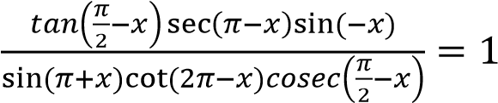



Find the number of words with or without meaning which can be made using all the letters of the word AGAIN. If these words are written in a dictionary, then what will be the 50th word.

Prove that 

How many words, with or without meaning each of 2 vowels and consonants can be flames from the letter of the word Daughter?

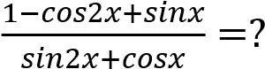

Prove that 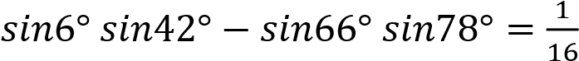

In an examination, a candidate has to pass in each of the five subjects. In how many ways can be fall?

31 b) 10 c) 21 d) 5

10. **Assertion (A):** Let A = {1, 2, 3} and B = {1, 2, 3, 4} Then, A⊂B.

**Reason (R):** If every element of X is also an element of Y, then X is a subset of Y. a) Both A and Rare true and R is the correct explanation of A.

Both A and Rare true but R. is not the correct explanation of A. c) A is true but R is false.

d) A is false but R is true.

11. **Assertion (A)**: The sum of infinite terms of a geometric progression is given by 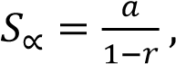 provided |r|<1.

**Reason (R)**: The sum of n terms of Geometric progression is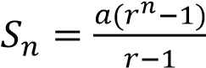.

Both A and Rare true and R is the correct explanation of A.

Both A and Rare true but R. is not the correct explanation of A. c) A is true but R is false.

d) A is false but R is true.

XI SCI HW

PHYSICS AUTUMN BREAK HOMEWORK

Complete the exercise of chapter - system of particles.

Submit investigatory project on the topics assigned by Oct 21, 2024.

Prepare your practical file with at least three practicals recorded and submit just after the autumn break.

KENDRIYA VIDYALAYA KALIMPONG

AUTUMN BREAK HOMEWORK

CLASS XI

SUB- CHEMISTRY

Autumn Break Holiday homework of class XI-A (2024)

Sub teacher– Mr. Rajat Subhra De

1. Prepare 30 MCQs from the following chapters…..

Some Basics concepts of Chemistry2.

Structure of Atom3.

Classifica on of Elements and Periodicity in Proper es4.

Chemical Bonding and Molecular Structure5.

Chemical Thermodynamics

2. Write Prac cal……

(a) Comparing the pH of solu ons of strong and weak acids of same concentra on.

(b)Study the pH change in the tra on of a strong base using universal indicator.

3. Prepare an Inves gatory Project in Chemistry on a Compound.

Study the acidity of different samples of tea leaves. [Roll No- 1 to 8]

Study of the methods of purifica on of water [Roll No- 9 to 16]

Inves ga on of the foaming capacity of different washing soaps and the effect of addi on of Sodium carbonate on it [ Roll No- 17 to 23]

KV Kalimpong

Autumn Break Homework 2024

Subject- Biology

Class- XI A

1.Solve PT 1 question paper & Worksheet in your classwork notebook.

2. Write down the practical “Study of osmosis by potato osmometer”

WORKSHEET

Name the simple lipid that is tri – hydroxyl propane.

Represent the zwitterion form of amino acid.

Write the formula of palmitic acid.

4)Give one example of heteropolysaccharide.

Molecular weight of lipids do not exceed 800 Daltons. Then why are they classified/or come under acid insoluble or macromolecular fraction?

What is the difference between nucleoside and nucleotide?

(A) Draw the structure of (i) phospholipid (lecithin) (ii) Adenylic acid.

(B)What is the difference between primary and secondary metabolites?

Differentiate between Prosthetic group, Co – enzyme and Metal ions with examples.

What do you mean by competitive inhibition? Explain with examples and labelled diagrams. How is it useful or beneficial to human beings?

9)Explain ‘Glycosidic bond’ and ‘Peptide bond’ with suitable diagrams.

10)

(a)Diagrammatically represent the types of chromosomes based on the position of centromere.

(b)What does chromatin contain?

©What is perinuclear space

**CLASS XI**

**PHYSICS**

**AUTUMN BREAK HOMEWORK**

1. Complete the exercise of chapter - system of particles.

2. Submit investigatory project on the topics assigned by Oct 21, 2024.

3. Prepare your practical file with at least three practicals recorded and submit just after

the autumn break.

**class 11 A and B**

**subject – Physical education**

1.All you have to do is complete your project file ..

2.Notebook: You have to complete chapter 5.

3.You have to make a chart paper based on the rules, regulations and measurement of any game.

AUTUMN BREAK HOMEWORK

CLASS: XI-B

SUBJECT: GEOGRAPHY

CONVERSION OF SCALE

Statement to R.F. Scale

Problem-1: 1 cm represents 1.5 km

Problem-2: 1 cm represents 25 metre

Problem-3: 1 inch represents 3 miles

Problem-4: 1 inch represents 5 feet

Problem-5: 1 inch represent 3 yards

R.F to Statement Scale

Problem-1: R.F. 1: 24

Problem-2: R.F. 1: 50,000

Problem-3: R.F. 1: 63360

Problem-4: R.F. 1: 108

Problem-5: R.F. 1: 200

Q.1) Draw a graphical scale with a R.F of 1: 2,00,000 to show 6 km on primary division and 2 km on secondary division.

Q.2) Draw a graphical scale with a R.F of 1: 50,000 to show 2 km on primary division and 1 km on secondary division.

Q.3) Draw a graphical scale with a R.F of 1: 63360 to show 1 mile on primary division and 4 furlongs on secondary division.

**KENDRIYA VIDYALAYA KALIMPONG**

AUTUMN BREAK HOME WORK

# SESSION 2024-25

CLASS – XI SUBJECT – ECONOMICS

1. Complete your Notebook.
2. Answer the following questions :-
   1. How can data be presented graphically for better interpretation? Present a bar diagram to show the distribution of income in five diWerent states of India.
   2. What are the key diWerences between primary and secondary data? Design a survey to collect primary data on household income in your locality.
   3. Explain the concept of consumer equilibrium using the indiWerence curve approach. How does a fall in the price of a good aWect consumer equilibrium?
   4. What is the relationship between marginal cost and average cost? Explain using a real-world example how a firm's production decisions are influenced by changes in marginal cost.
   5. Why is it important to use data in economic analysis? Explain with an example how statistical data can help policymakers in addressing the issue of unemployment.

**KENDRIYA VIDYALAYA KALIMPONG**

**AUTUMN BREAK HOME WORK**

**SESSION-2024-25**

CLASS XI-B SUBJECT- HISTORY TEACHER: -SN CHOUDHARY, PGT HISTORY

1. Write in brief about the importance of southern and north-east regions of Mesopotamia.

2. “The Euphrates River of ancient Mesopotamia was world-renowned trade route”. How will

you justify it?

3. If you had lived in the Roman Empire, where would you rather have lived—in the towns

or in the countryside? Explain why?

4. Pick out some basic features of Roman society and economy which you think make it look

quite modern.

5. Discuss the causes of the success of Genghis Khan.

6. Describe the main characteristics of the Mongol society in 12th century.

**KENDRIYA VIDYALAYA KALIMPONG**

**HOLIDAY HOME WORK (AUTOMN BREAK)**

**SUBJECT:- COMPUTER SCINCE AND AI**

**CLASS XI:-**

Solve the questions of unit 1. Computer organisation, flow of control and string.

Design the programs in practical note book given in soft copy.

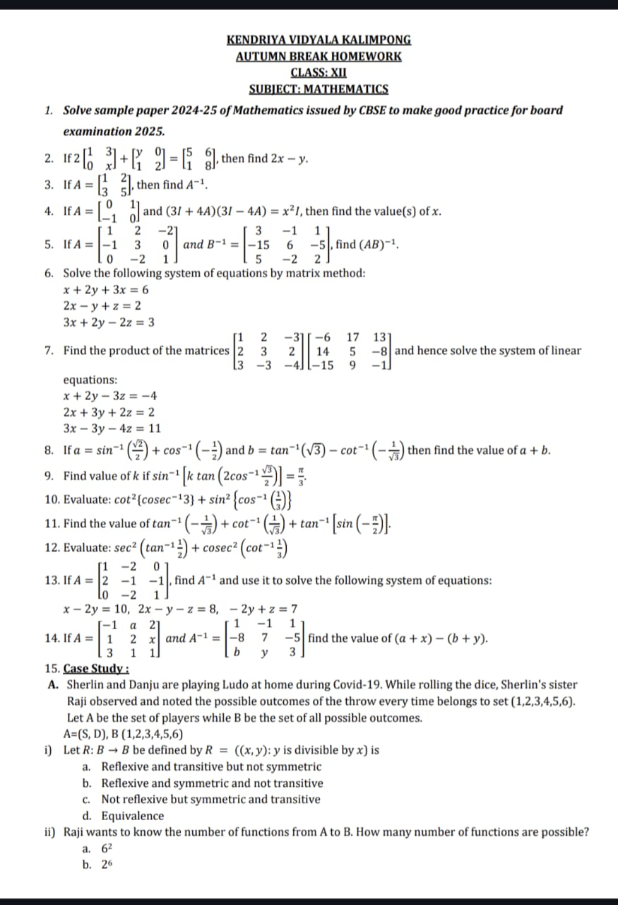

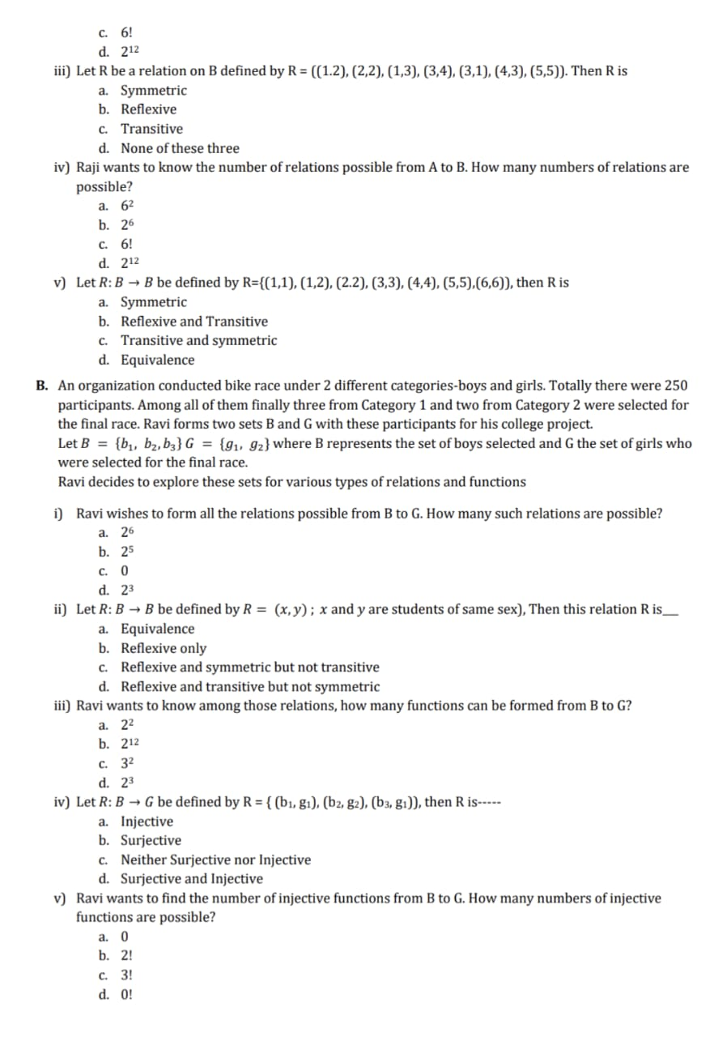

**KENDRIYA VIDYALAYA KALIMPONG**

AUTUMN BREAK HOME WORK

# SESSION 2024-25

CLASS – **XII SUBJECT – ECONOMICS**

1. Solve CBSE Economics Sample Paper 2024-25 in your Economics Notebook.
2. Complete your Notebook.
3. Answer the following questions :-
   1. Discuss how an increase in foreign direct investment (FDI) aZects the exchange rate in an open economy. What are the implications for India's trade balance?
   2. Compare the economic growth experiences of India and China. What lessons can India learn from China's development strategy?
   3. How can economic growth be reconciled with environmental sustainability? Discuss with reference to India’s sustainable development goals.
   4. How has the shift from formal to informal employment impacted income inequality in India? Provide examples to explain your answer.

How does investment in education contribute to human capital formation? Illustrate your answer with India's experience postindependence

कक्षा 12वीं हेतुशरदकालीन अवकाश के लि ए गहृकार्य

1. तलु सीदास जी नेअपनेकाल की आर्थि कर्थि दशा का वर्णनर्ण कि स प्रकार कि या है?

2. राम जी नेयह बात क्यों कही कि लक्ष्मण जसै ा भाई इस ससं ार मेंदसू रा कोई नहीं है?

3. 'बादल राग' कवि ता का सारांश अपनेशब्दों मेंलि खें।

4. 'शि रीष के फूल’ द्वि वेदी जी का एक सदं ेशपरक नि बधं है। इसमेंलेखक नेजो सदं ेश दि या है, उसको अपने

शब्दों मेंलि खि ए।

5. 'उषा' कवि ता मेंसबु ह की तलु ना कि न कि न चीज़ों सेकी गई है? अपनेशब्दों मेंलि खि ए।

6. गाँव मेंमहामारी फैलनेएवं अपनेबेटेकी मत्ृयुके बावजदू भी लट्ुटन पहलवान ढोलक क्यों बजाता रहा?

अपनेशब्दों मेंउत्तर दीजि ए।

**KENDRIYA VIDYALAYA KALIMPONG**

**AUTUMN BREAK HOMEWORK SUB: ENGLISH**

**CLASS XII. SESSION 2024-25**

1.Solve the CBSE Sample Paper in your English Notebook.

2. Complete your previous c/w, h/w and notes.

3. Read the extract and answer the questions that follow:

MR. LAMB : Like a bomb only blew up my leg. There’s worse things can happen. You can

burn yours

elf away inside.

DERRY : After I’d come home, one person said, “He’d have been better off stopping in there.

In the

hospital. He’d be better off with others like himself.” She thinks blind people only ought to be

with other

blind people and idiot boys with idiot boys.

MR. LAMB : And people with no legs altogether?

DERRY : That’s right.

MR. LAMB : What kind of a world would that be?

i. What do the given lines tell about the relationship between Mr. Lamb and Derry?

ii. Select the option that best describes the stranger’s belief regarding people like Derry?

(a) That there should be a place where all people like him could stay together.

(b) That he would not live for long and so should stay at home.

(c) That no one would love him and he would be alone forever.

(d) That he should stop being a burden.

iii. The attitude shown by ‘she’ in the extract is _____.

iv. What does ‘you can burn yourself away inside’ mean?

4. Read the extract and answer the questions that follow:

The news of Gandhi’s advent and of the nature of his mission spread quickly through

Muzaffarpur and

to Champaran. Sharecroppers from Champaran began arriving on foot and by conveyance

to see their

champion. Muzaffarpur lawyers called on Gandhi to brief him; they frequently represented

peasant

groups in court, they told him about their cases and reported the size of their fee.

i. What was the nature of Gandhi’s mission as mentioned in the passage?

ii. The cases referred to in the extract were the cases fought against _____.

(a) the Lawyers (b) the British Landlords

(c) East India Company (d) the Indian Zamindars

iii. What does ‘their cases’ refer to in the extract? 1

iv. Complete the sentence with an appropriate explanation. 1

The fact that the sharecroppers from Champaran began arriving on foot shows that _____.

v. Identify the textual clue that allows the reader to infer that the lawyers did not care for the

condition of

the poor.

5. Imagine you are an ardent environmentalist who is involved in the Save the Tiger

campaign. You have

been asked to deliver a speech in a seminar related to your campaign and the need for the

youth to be

involved in such campaigns. Draft your speech.

**KENDRIYA VIDYALAYA KALIMPONG**

**AUTUMN BREAK HOMEWORK**

**CLASS XII**

Holiday HW **of Chemistry of XII for** Autumn Break-2024

1-Solve sample paper-2024-25 of Chemistry issued by CBSE to make good pracƟse for

incoming 2025 Exam.

2-Write equaƟon for disƟncƟon test b/n

(I) Methanol & Ethanol

(II) Pentanone-2 & Pentanone-3

(III) Phenol & Benzoic acid

(IV) CH3CHO & CH3COCH3

3-Write short notes on

(I) Stephen ReducƟon

(II) Clemmensen ReducƟon

(III) Wolf Kushner ReducƟon

(IV) Reimer Tiemann ReacƟon

(V) Williamson synthesis

(VI) GaƩerman Koch reacƟon

(VII) Hoffman Bromamide ReacƟon

(VIII) Carbyl amine reacƟon

(IX) Iodoform Test

(X) Cannizzaro ReacƟon

(XI) Rosenmund ReducƟon

(XII) Friedel craŌ acylaƟon

4-Write definiƟon…..

a. Non ideal soluƟon

b. Kohlrausch's Law

c. Henry's Law

d. Faraday 1st and 2nd Law

**KENDRIYA VIDYALA KALIMPONG**

**AUTUMN BREAK HOMEWORK**

**CLASS: XII**

**SUBJECT: PHYSICS**

1. Make investigatory project on alloted topics and submit it on Oct 21, 2024.

2. Solve CBSE Sample Paper 2024 in your CW Notebook.

3. Revise all derivations taught from Unit 01 to Unit 06 in CW notebooks as revision

for MT05.

**KV Kalimpong**

**Autumn Break Homework**

**Subject- Biology**

Class –XII A

1. Solve CBSE Sample paper in your Classwork notebook.

2. Complete your Practical till date, and also write down the Core Experiment -Prepare a temporary

mount of onion root tip to study mitosis.

3. Complete an investigatory project on the following

Topics:

• Drug Addiction (Roll no.1-3)

• Amniocentesis (Roll no.4-8)

• Infertility causes and its treatment ( Roll no.9,10,12)

• Cancer cause & its treatment( roll no.13,15, 16, )

• Vector of disease: Malaria(17,18,20)

• Transgenic organism (roll no.21,22,23)

• Biodiversity conservation ( roll no. 24-26)

Note: Project must be done in A4 sheet paper.

4. Revise the topics which have already taught in the class.

**KENDRIYA VIDYALAYA KALIMPONG**

**AUTUMN BREAK HOME WORK**

**SESSION-2024-25**

CLASS XII-B SUBJECT- **HISTORY TEACHER**: -SN CHOUDHARY, PGT HISTORY

1. Solve three CBSE Sample papers of Board Exam and write them with answers in your history

note book. (will be shared to you)

2. Complete your notebook up to chapter-9 Colonialism and Countryside.

3. Bring 11 maps of India and mark the following and paste them in your history notebook: -

a) Mature Harappan sites: Harappa, Banawali, Kalibangan, Balakot, Rakhigarhi, Dholavira,

Nageshwar, Lothal, Mohenjodaro, Chanhudaro, KotDiji.

b) Mahajanapada and cities: Vajji, Magadha, Kosala, Kuru, Panchala, Gandhara, Avanti, Rajgir,

Ujjain, Taxila, Varanasi.

c) Distribution of Ashokan inscriptions: Pillar inscriptions – Sanchi, Topra, Meerut Pillar and

Kaushambi.

d) Kingdom of Cholas, Cheras and Pandyas.

e) Important kingdoms and towns: Kushanas, Shakas, Satavahanas, Vakatakas,Guptas

f) Cities/towns: Mathura, Kanauj, Puhar, Braghukachchha, Shravasti, Rajgir, Vaishali,

Varanasi,Vidisha

g) Major Buddhist Sites: Nagarjunakonda, Sanchi, Amaravati, Lumbini, Bharhut, Bodh Gaya,

Ajanta, Bidar, Golconda, Bijapur, Vijayanagar, Chandragiri, Kanchipuram, Mysore, Thanjavur,

Kolar, Tirunelveli

h) Territories under Babur, Akbar and Aurangzeb: Delhi, Agra, Panipat, Amber, Ajmer, Lahore,

Goa.

i) Territories/cities under British Control in1857: Punjab, Sindh, Bombay, Madras Berar, Bengal,

Bihar,Orissa, Surat, Calcutta, Patna, Allahabad

j) Main centres of the Revolt of 1857: Delhi, Meerut, Jhansi, Lucknow, Kanpur, Azamgarh,

Calcutta, Benaras, Gwalior, Jabalpur, Agra, Awadh

k) Important centres of the National Movement: Champaran, Kheda, Ahmedabad, Benaras,

Amritsar, Chauri Chaura, Lahore, Bardoli, Dandi, Bombay (Quit India Resolution), Karachi

**KENDRIYA VIDYALAYA KALIMPONG**

**HOLIDAY HOME WORK (AUTOMN BREAK)**

**SUBJECT:- COMPUTER SCINCE AND AI**

**CLASS XII:-**

CLASS XII:-

Solve the CBSE Sample Paper question papers of year 2024-25 and 2023-24, soft copy already given.

Prepare the project as per CBSE guidelines and execute the code and bring in pen drive.

Prepare Practical records up to MY SQl , soft copy already given.

**class 12 A and B**

**subject- Physical Education**

1.All you have to do is complete your project file ..

2.Notebook: You have to complete chapter 6.

3.You have to make a chart paper based on the rules, regulations and measurement of any game.

**AUTUMN BREAK HOMEWORK**

**CLASS: XII-B**

**SUBJECT: GEOGRAPHY**

Answer the following questions-

1. “The density and quality of roads are better in plains as compared to other regions in India”. Support the statement with examples.

2. “Indian railways brought people of diverse cultures together.” Support this statement with suitable examples.

3. " Konkan Railway is considered an engineering marvel” Support the statement with suitable examples.

4. Describe the composition of export and import trade of India.

5. Mention the characteristics of India’s foreign trade.

6. Why are the ports called the gateway of international trade?

7. Discuss advantages and disadvantages of pipeline transportation.