KENDRIYA VIDYALAYA KALIMPONG
SESSION ( 2020 –21 )
WINTER BREAK --- HOLIDAY HOMEWORK
CLASS : IV SUBJECT : EVS TEACHER : Mrs.Prisca Phipon.

- Read the instructions carefully and perform the activity under the guidance of your parents ( if needed. )
- Some examples are given here , you can take idea from these.
SUBJECT ENRICHMENT ACTIVITY FOR DECEMBER
POSTER MAKING ON --- SAVE WATER , SAVE LIFE.

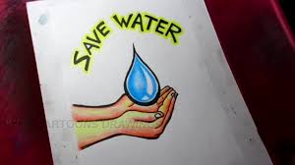

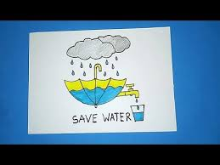

- Submit your activity ( ONLY ONE DRAWING ) when school reopens after 20 days winter break ( in whatsapp group ).

शीतावकाश गृहकार्य कक्षा -४

१. किसी चिड़िया के बारे में पांच वाक्य लिखिए ।
२. हुदहुद का चित्र बनाइए।
३.दस पक्षियों और दस जंगली जानवरों के नाम लिखिए।
४. आपका मित्र मोटरसाइकिल से गिर गया है उसे एक पत्र लिखिए और उसका उसका हाल पूछिए।
५.पकौड़ी बनाने की विधि लिखिए।
६. सात महासागरों के नाम लिखिए।
७.हिंदी के बारह महीनों के नाम लिखिए।

WINTER HOLIDAY HOME WORK Class-IV
ENGLISH
1.Do the following activity in a chart paper, colour the pictures:
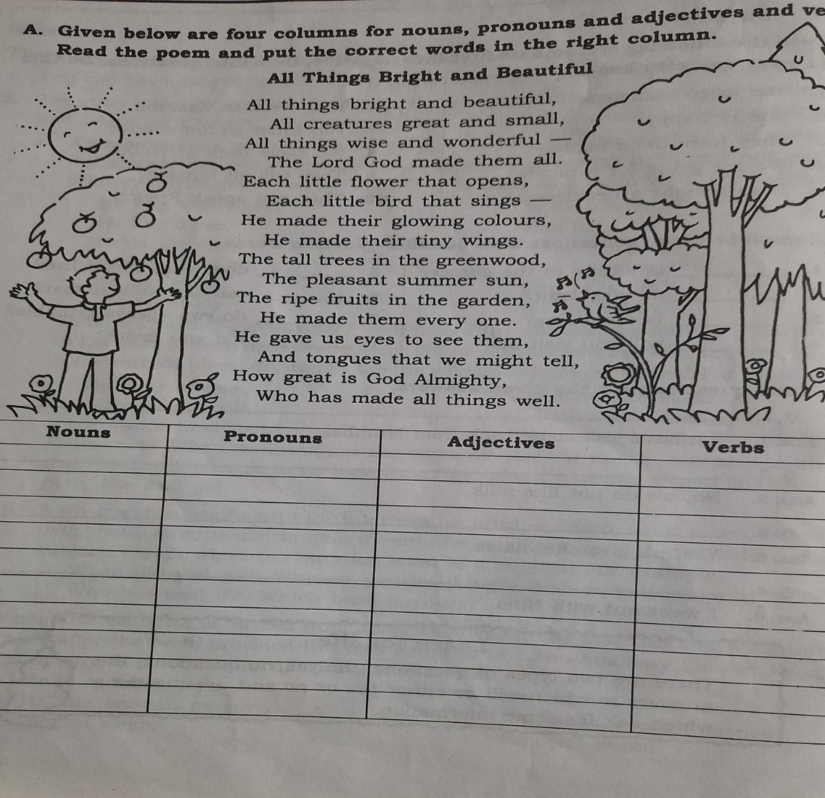
verb

- What are the things that are bright and beautiful?

Ans.__________________________________________________________

- Who made them all?

Ans.__________________________________________________________

(Submit after winter holiday)

WINTER HOLIDAY HOME WORK
Class-IV MATHEMATICS
- Learn Multiplication Tables from 6-17.
- Do the following activity:
Different things that usually bought in grams and kilo grams in your house, in the following format:
THINGS BOUGHT IN GRAMS | THINGS BOUGHT IN KILO GRAMS

3.Make the Health Chart of your family members and your friends like the following chart:
Name | Age | Height | Weight
(Submit after winter holiday)

